Project Report Template

1. INTRODUCTION

1.1 Overview

The Lok Sabha, constitutionally the House of the people, is the lower house of india’s bicameral parliament, with the upper house being the Rajya Sabha. Members of the Lok Sabha are elected by an adult universal suffrage and a first-past-the-post system to represent thir respective constituencies, and they hold their respective constituencies, and they hold their seats for five years or until the body s dssolved by the President on the advice of the council of ministers. The house meets n the Lok Sabha Chambers of the Parliament House, New Delhi. The maximum membership of the House allottedby the Constitution of India. Lok Sabha, is House of the people the lower chamber of ndia’s bicameral parliament. Under the constitution of 1950,ts members are directly elected for a term of fve years by territorial constitunencies in the states. In our country, the Parlament consistsof two House. The two House are known as the Council of States (Rajya Sabha) and the House of the People (Lpk Sabha). The current elected strength of the Lok Sabha ia 543. The party—or coalition of parties—havng a majority in the Lok Sabha chooses the Prime Minister of India. The Lok Sabha  composed of representatives of people chosen by direct election on the basis of Universal Adult Suffrage.

* 1. Purpose

The Lok Sabha has certain powers that make it more powerful than the Rajya Sabha. Motions of no confidence against the government can be introduced and passed in the Lok Sabha. If passed by a majority vote, the Prime Minister. The Lok Sabha and Rajya Sabha alter the Indian Constitution. Both houses of parliament have the power to appoint and dismiss judges from the High Court and Supreme Court. The Rajya Sabha must have the consent of the members of the Lok Sabha to remove the Vice-President. The Lok Sabha has certain powers that make it more powerful than the Rajya Sabha. Motions of no confidence against the government can be introduced and passed in the Lok Sabha. If passed by a majority vote, the Prime Minister and the Council of Ministers resign collectively.   
Lok Sabha is the House of Representatives directly elected by the people. Hence, the Lok Sabha is called the 'First' house. The members of Lok Sabha are elected directly by people from the 'territorial constituencies'. The tenure of Lok Sabha is five years. Through these advisory committees, the parliament controls the public council. -Article 75 of the constitution refers that the council of ministers stays in office as long as it relishes the confidence of the Lok Sabha. Lok Sabha can eliminate the council of ministers by passing a no-confidence motion in the Lok Sabha. The Sabha advised the king on administration.

2 Problem Definition & Design Thinking

* 2.1 Empathy Map

Member of Lok Sabha

Something that is extremely large and powerful and cannot be stopped one of the most important function of the lok sabha is to select the election. It has a large membership than the rajya sabha.

Election are there Lok Sabha

The Lok Sabha election are conducted once in 5 years by the Election Commission of india to elect members to the lower house of india’s parliament. Election take place once in five year to elect 543 member for the lok sabha

Lok Sabha Election

Member of the Lok Sabha are elected by an adult universal suffrage and a first-past – the- post system to represent their respective constituencies, and they hold their seats for five year or until the body is dissolved by the president on the advice of the council of ministers.

. First Lok Sabha

The First Lok Sabha was constituted on 17 Apeil 1952 after India’s fest general election The 1st Lok Sabha lasted its full tenure of five years ans was dissolved on 4 April 1957. The First Session of this Lok Sabha commenced on 13 May 1952 . Total Lok Sabha seats were 489 and total eligible voters were 17.3 crores

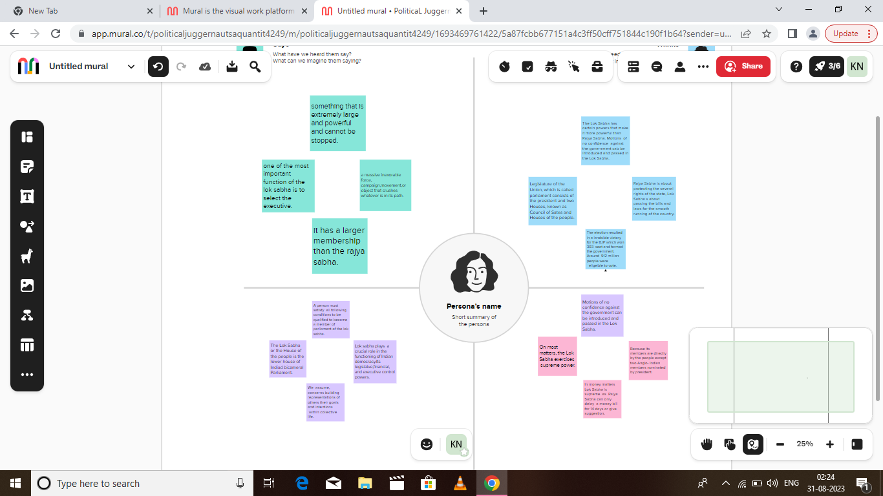

2.2 Brainstorming Map

Statistics of Lok Sabha election 2019

The Bharatiya Janata Party received 37.36% of the vote, the highest vote share by a political party since the 1989 general election, and won 303 seats, further increasing its substantial majority. In addition, the BJP-led National Democratic Alliance (NDA) won 353 seats.2

 Majority in Lok Sabha

Since there are 543 elected (plus 2 Anglo-Indian nominated) members in Lok Sabha, to have a majority a party should have at least half the number i.e. 272 members or more.

Quorum of Lok Sabha in percentage

The quorum of the Lok Sabha and the Rajya Sabha is One-tenth of the total membership of each house. The quorum to constitute a sitting of the House is one-tenth of the total number of members of the House, for both Lok Sabha as well as Rajya Sabha.

Majority in Parliament

The composition of both chambers is as follows: Azimio la Umoja makes up the majority in the National Assembly, while Kenya Kwanza has the majority in the Senate.

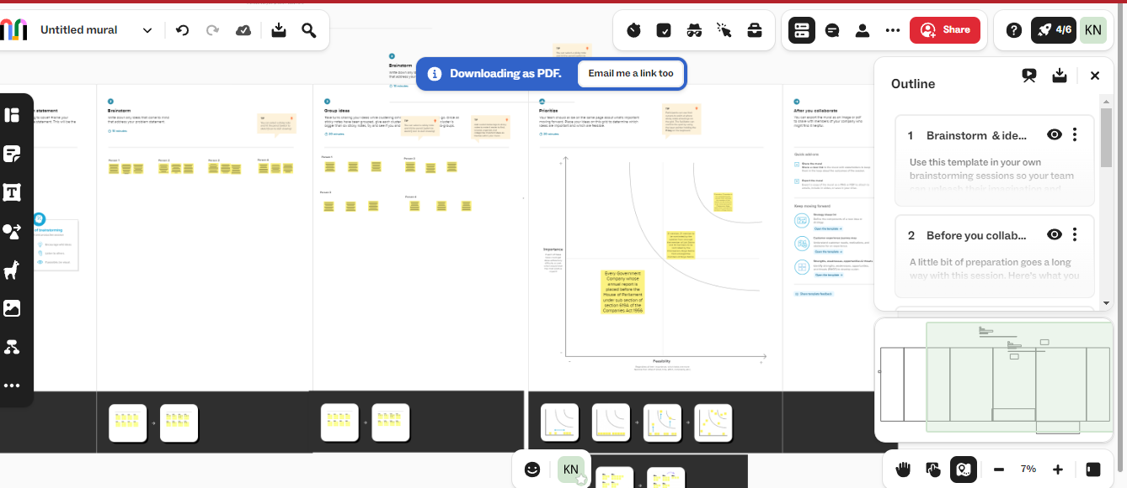

3 RESULT

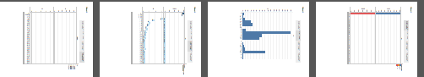

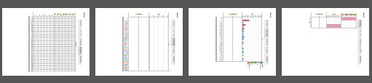

4 ADVANTAGES AND DISADVANTAGES

Advantages:

The biggest logic in the favor of the simultaneous election is the saving of government money. If the country goes for One Nation One Election it will saving of huge Government money. As per reports, a whopping Rs 60,000 crore was spent on the 2019 Lok Sabha elections. The amount includes what was spent by the political parties fighting the polls and the spending by the Election Commission of India (ECI) to hold the elections. The move might also lead to an increase in voter percentage and lesser corruption, besides saving time and energy.

Disadvantages:

It is observed that elections for state assemblies and LokSabha are fought on different issues. Regional parties target local issues while national parties target national issues. So there is a possibility that regional parties will not be able to raise the local issues strongly.

Regional parties will not be able to compete with national parties in terms of election expenditure and election strategy. are closely associated with the local issues and local voters. Hence one time election will not be accepted by the regional parties.

5 APPLICATION

Member of **Lok Sabha**. (Identity Card No ... This **application** will not be entertained if all the particulars Mrequired above have not been furnished.

1. CONCLUSION
2. It is transparent that the total number of votes in Maharastra, Uttar Pradesh, and West Bengal are very much higher than the remaining states in India and Uttar Pradesh holds first place in the total number of votes.
3. The number of female candidates is very less than the number of male candidates.
4. Unfortunately, we found that the candidates of Kerala have maximum criminal cases history, and West- Bengal, Uttar Pradesh, and Telangana are not far behind. The maximum no of criminal cases done by a single person is 240 and he is from Kerala.
5. We have noticed that the history of the criminal case of candidates is maximum at the age of 49,37, and 51.

7 APPENDIX

https://github.com/bdu1621me1284/NM2023TMID25624/upload/main